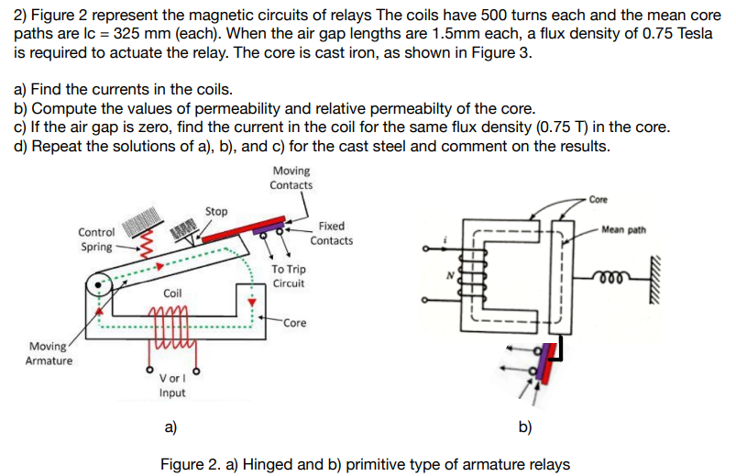

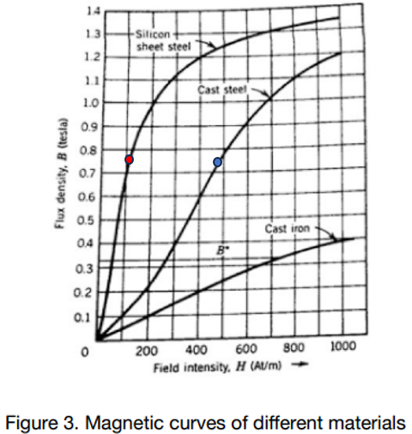

- Find the currents in the coils.

For the current calculation we can use the following equation.

$$F=NI=Hl_{c}$$

As you can see in Figure-3, We know the magnetic flux density is 0.75 T. So, we can use the H for the Silicon Sheet Steel as 110 (At/m).
For the MMF (Magnetomotive Force) in the Core,
$$F=Hl_{c}$$
$$F_{c}=110*0.325=35.75 (At)$$

MMF (Magnetomotive Force) for the Air Gap,
$$F_{g}=H{2l}_{g}=\frac{β{2l}_{g}}{μ_{0}}$$
Air gap lengths are 1.5mm each. The permeability of free space is 4πx10⁻⁷. Magnetic Flux Density is 0.75T.
$$F_{g}=\frac{0.75*2*1.5*{10}^{-3}}{4*π*{10}^{-7}}=1790.5 (At)$$
Total MMF:
$$F=F_{c}+F_{g}=35.75+1790.5=1826.3 (At)$$
Therefore, the current in the coil is
$$i=\frac{F}{N}=\frac{1826.3}{500}=3.65 A$$
- Compute the values of permeability and relative permeability of the core.

We can use the following equations for calculating permeability and relative permeability.

For the core permeability

$$μ_{c}=\frac{β}{H}=\frac{0.75}{110}=0.006818 (H/m)$$

For the relative permeability

$$μ_{r}=\frac{μ_{c}}{μ_{0}}=\frac{0.006818}{4*π*{10}^{-7}}=5425.6$$

- If the air gap is zero, find the current in the coil for the same flux density (0.75 T) in the core.

We can use the same following equation for calculating current.
$$F=NI=Hl_{c}$$
$$F_{c}=110*0.325=35.75 (At)$$

Therefore, the current in the coil is

$$i=\frac{F_{c}}{N}=\frac{35.75}{500}=0.0715 A$$
- Repeat the solutions of a), b), and c) for the cast steel and comment on the results.

- Find the currents in the coils.
We can use the same steps as above for the current calculation.

$$F=NI=Hl_{c}$$
As you can see in Figure-3, We know the magnetic flux density is same 0.75 T. So, we can use the H for the cast steel as 475 (At/m).

For the MMF (Magnetomotive Force) in the Core,
$$F=Hl_{c}$$
$$F_{c}=475*0.325=154.4 (At)$$

MMF (Magnetomotive Force) for the Air Gap,
$$F_{g}=H{2l}_{g}=\frac{β{2l}_{g}}{μ_{0}}$$
Air gap lengths are 1.5mm each. The permeability of free space is 4πx10⁻⁷. Magnetic Flux Density is 0.75T.
$$F_{g}=\frac{0.75*2*1.5*{10}^{-3}}{4*π*{10}^{-7}}=1790.5 (At)$$
Total MMF:
$$F=F_{c}+F_{g}=154.4+1790.5=1944.9 (At)$$

Therefore, the current in the coil is
$$i=\frac{F}{N}=\frac{1944.9}{500}=3.9 A$$
- Compute the values of permeability and relative permeability of the core.

We can use the following equations for calculating permeability and relative permeability.

For the core permeability

$$μ_{c}=\frac{β}{H}=\frac{0.75}{475}=0.001579 \left(H/m\right)$$

For the relative permeability
$$μ_{r}=\frac{μ_{c}}{μ_{0}}=\frac{0.001579}{4*π*{10}^{-7}}=1256.5$$
- If the air gap is zero, find the current in the coil for the same flux density (0.75 T) in the core.

We can use the same following equation for calculating current.

$$F=NI=Hl_{c}$$
$$F_{c}=475*0.325=154.4 (At)$$

Therefore, the current in the coil is

$$i=\frac{F_{c}}{N}=\frac{154.4}{500}=0.31 A$$

